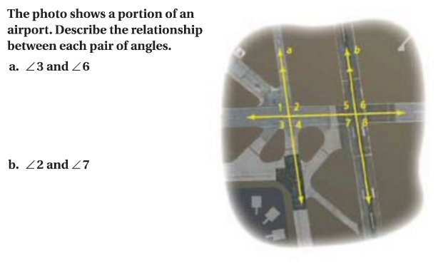

The photo shows a portion of the airport. If <1 is 106 degrees find the measure of the following angles. Justify your answer in 2 different ways.

1. <8=

Justify :

Justify:

1. <7=

Justify:

Justify:

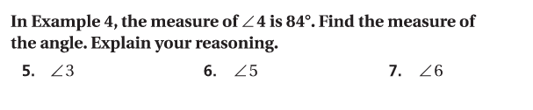

If <4 is 84 degrees. Find the measure of the following angles. Justify your answer in 2 different ways