Name Date

Practice A

2.5

1. Name the corresponding angles and the corresponding sides of the   
similar figures.

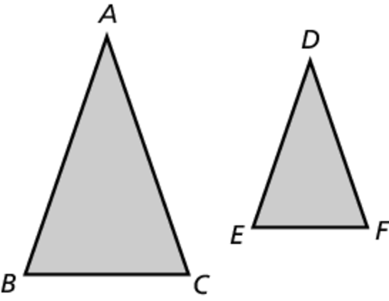

2. Tell whether the two figures are similar. Explain your reasoning.

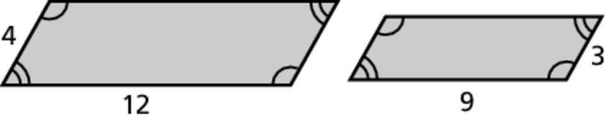

3. The rectangular traffic sign is 18 inches wide and 8 inches tall. The rectangular realtor sign is 27 inches wide and 10 inches tall. Are the   
signs similar?

4. The given rectangle needs to be modified.

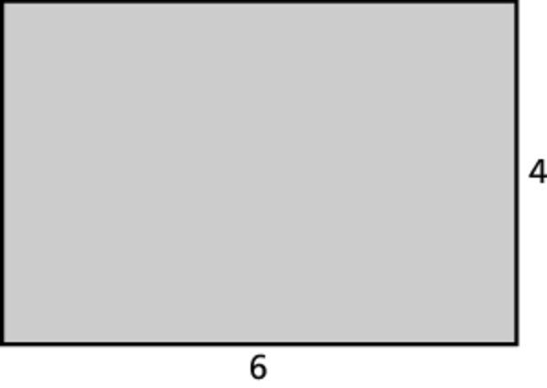

a. Each side length is increased by 2.

Is the new rectangle similar to the original?

b. Each side length is increased by 50%.

Is the new rectangle similar to the original?

5. Which of the following card dimensions are similar rectangles?

2 in. by 5 in. 3 in. by 6 in.

1 in. by 3 in. 1 in. by 2.5 in.

Practice A-Similar Figures

2.7

Practice A-Similar Figures from Dilations

2.7

The vertices of a figure are given. Draw the figure and its image after a dilation with the given scale factor. Identify the type of dilation.

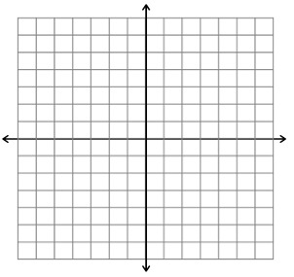 1. 

2. 



The dashed figure is a dilation of the solid figure. Identify the type of dilation and find the scale factor.

3. 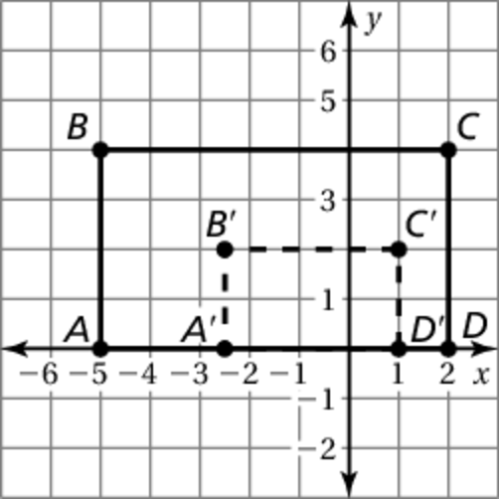 4.