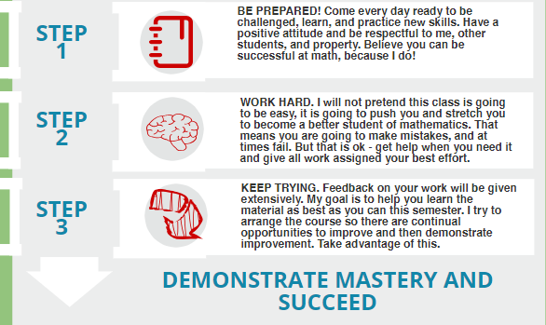Steps to Success

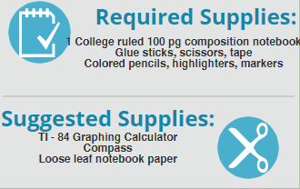Materials

Many supplies are provided in the classroom for student use. However, individual damage to supplies will require replacement of materials and possible loss of using Ms. Colville’s materials.

3 Ring Binder 1 1/2 “, 5 Tab Divider, pencils, and checking utensils

fx-260 solar calculator, protractor, book cover

Course Details

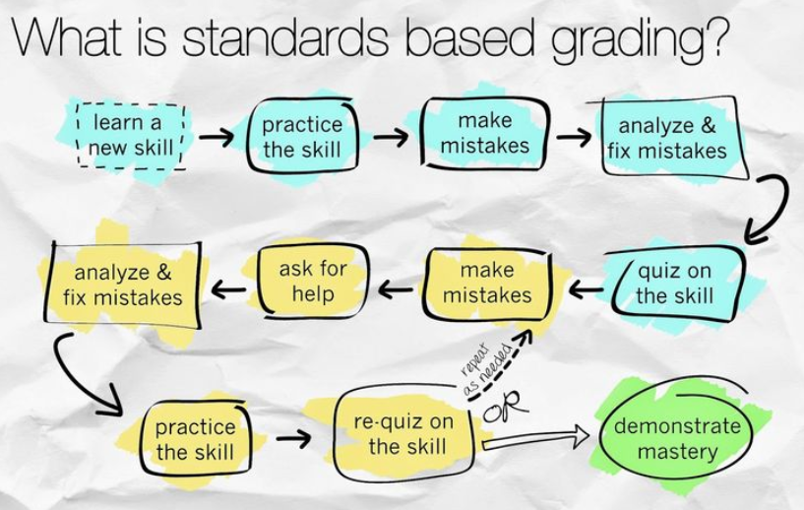Grading

Grade Breakdown:

70% Concept Quizzes

15% Unit Tests

15% Daily Practice

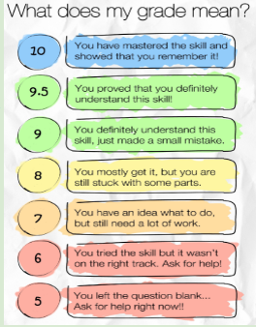

Daily Practice

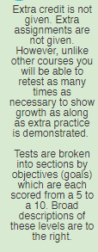



While daily practice (homework, warmups, classwork, etc.) are not “graded” for accuracy they are vital for improving before tests and quizzes that determine your grade. Feedback will be given to help you improve and analyze your errors before and after. I can only help you effectively if you are giving genuine effort and attempts on these assignments.