Name______________________________________Date_______________hr______

Warm up: Rationals_Fractions_Mixed to Improper

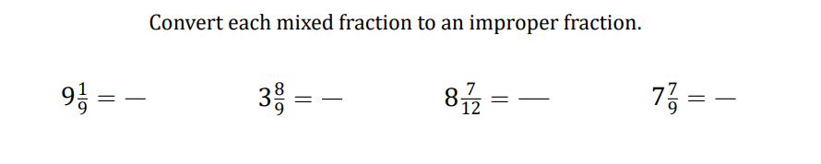

Name______________________________________Date_______________hr______

Warm up: Rationals

