Name_____________________________________Date_______________Hr_________

Warm up-Percent of Change and Simple Interest

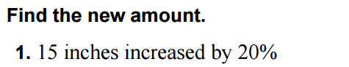

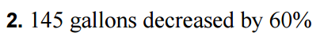

Find the percent change. Describe if it is an increase or decrease.

- 25 points to 56 points.

