Name Date
Warm up
Ch 3
Find the measure of the exterior angle.
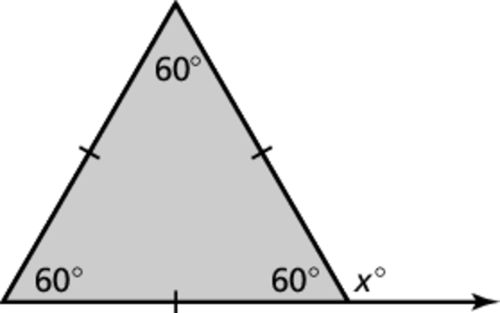
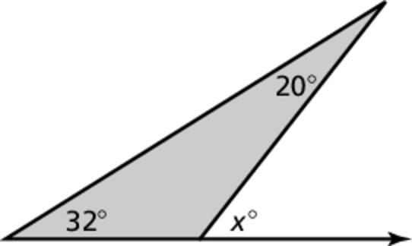
1. 2.

Find the measures of the interior angles.
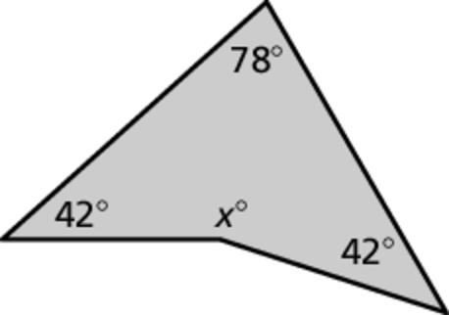
3.
4. A stop sign is in the shape of a regular octagon (8 sided). What is sum of the internal angles?

Find the measures of the exterior angles of the polygon.
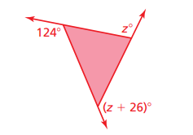
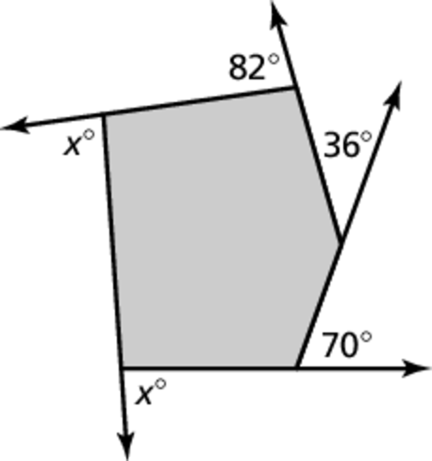
5. 6.

