Name ___________________________ Date________ Hour________
Super Bear – Proportions Practice
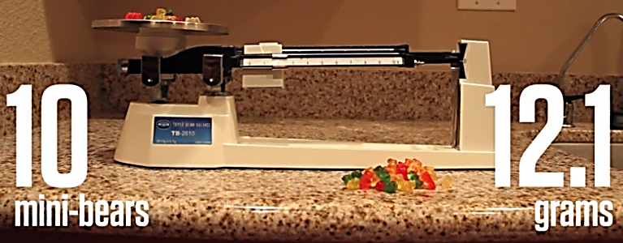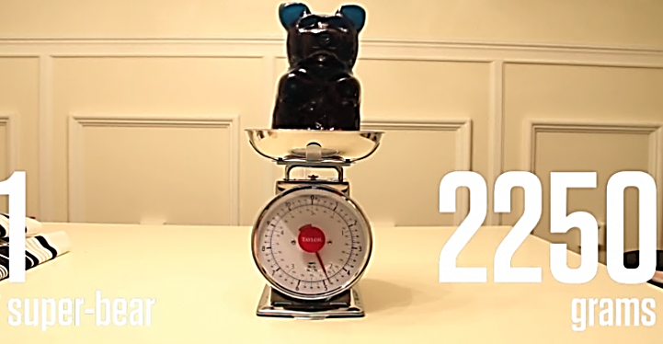
- Using the measurements from above, set up and solve a proportion for how many mini-gummy bears have the same mass as super bear.

- Using a proportion, how many mini-gummy bears could you buy with $20?

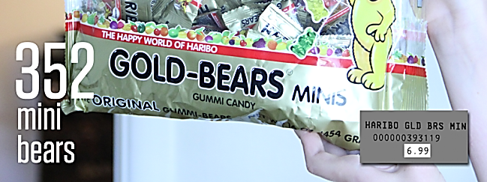

$6.99

- Using a proportion, how many regular-gummy bears could you buy with $20?

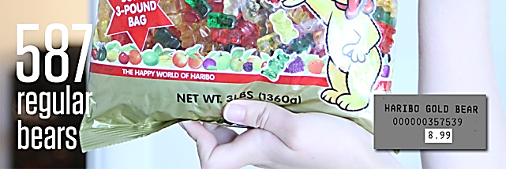

$8.99

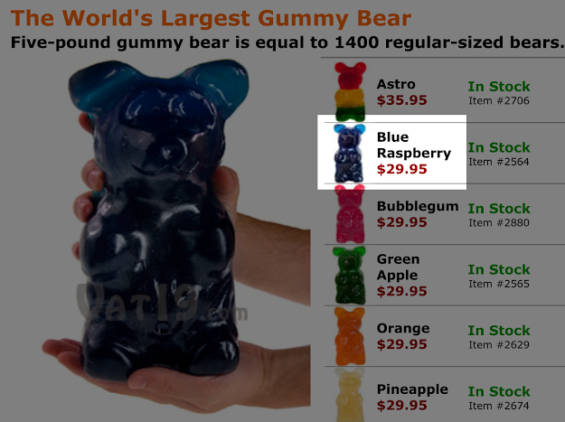
- Using a proportion, how many regular gummy bears (refer to #3) cost the same amount as a super bear?

- The ad for super bear claims that it is equal to 1,400 regular-sized bears. We calculated super bear to have the same mass as 974 regular-sized gummy bears. Explain why the ad could be off by over 400 regular-gummy bears.

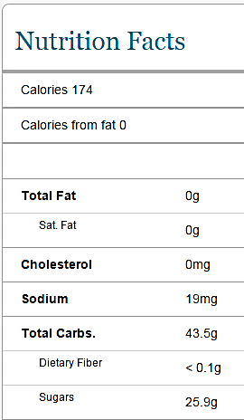
- The label below shows the nutritional information for 20 regular-sized gummy bears. Using a proportion, how many calories would a super bear have (remember 974 regular gummy bears have the same mass as one super bear)?

