Name_______________________________________________Date_______________hr________

**Warm up- Percent and Unknowns**

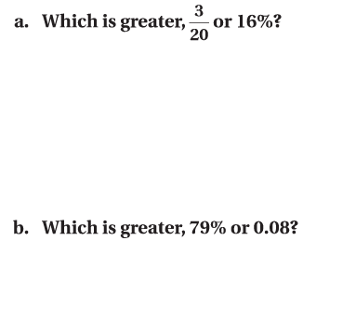





**c. d.**

**e. Alyssa took a quiz in math. There were 40 available points. Alyssa earned 28 points on the**

**quiz. What percent did Alyssa get on her quiz?**

