Linear Equations - Introduction
Name _____________________________________ Date ______________ Hour ___________
Complete each of the tables below. Then, graph the points on the coordinate graph provided.
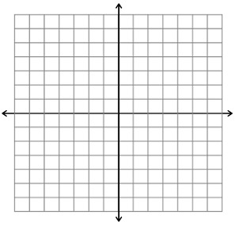
1. $y=2x+1$

x | y
-2
-1
0
1
2

2. $y=-2x+1$
x | y
-2
-1
0
1
2

3. What similarities / differences do you notice?

4. $y=-3x+5$

x | y
-2
-1
0
1
2

5. $y=-3x-5$
x | y
-2
-1
0
1
2

6. What similarities / differences do you notice?

7. $y=\frac{1}{2}x-4$
x | y
-2
-1
0
1
2

8. $y=2x-4$
x | y
-2
-1
0
1
2

9. What similarities / differences do you notice?

10. What effect did the number in front of the x-variable have on the graph and table?

11. What effect did the number without the x-variable have on the graph and table?

12. What do you think makes a relationship linear?

