Adding Integers:
- Visit the following Blendspace (There is also a link to this on Moodle):
- https://www.tes.com/lessons/ct8OxqISilQxaw/integer-operations
- Watch Video 1 & 2.
- Complete the following problems:
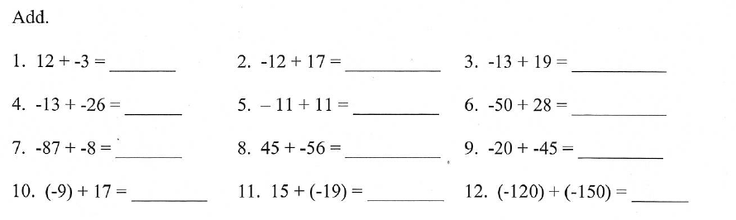

- Check your answers. If you did not get them correct, try again. If you did get them correct get Mrs. Wuerth’s initials! Complete any other sections that are necessary.

Subtracting Integers:
- Visit Blendspace.
- Watch videos #3 then 1.
- Complete the following problems:
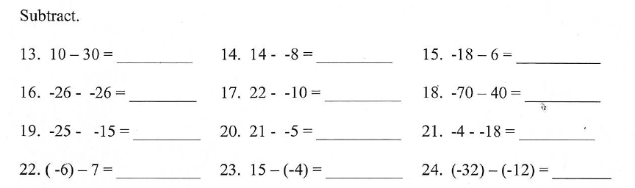

- Check your answers. If you did not get them correct, try again. If you did get them correct get Mrs. Wuerth’s initials! Complete any other sections that are necessary.

Multiplying and Dividing Integers:
- Visit Blendspace.
- Watch videos #4 & 5.
- Complete the following problems:
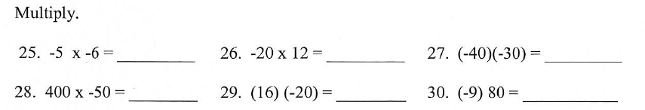

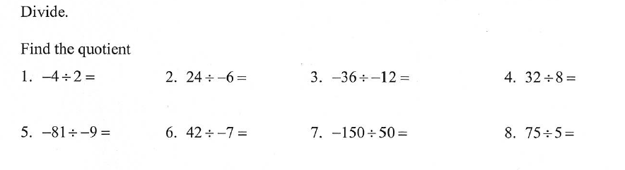
- Check your answers. If you did not get them correct, try again. If you did get them correct get Mrs. Wuerth’s initials!

If you got all of the problems right (Group D):
YAYYYYYYYYYY!!!!!! You can play an integer math game. Links are provided on the blendspace.

