Name _____________________ Date ____________ Hour _________
7th Grade Advanced – Unit 3 - Study Guide
The Term 3 Assessment will cover the following concepts:
Review of Term 3 Concepts:

Unit 3-Part 1
13 - Slope
14 - Slope-Intercept Form
15 - Standard and Point-Slope Forms

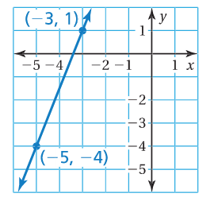
Find the slope of the line.
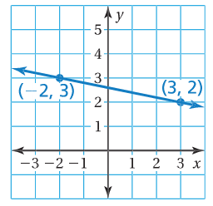
1. 2.

Find the slope of the line through the given points.
3. (1, -2), (7, -2) 4. (-2, 4), (3, 4)

The points in the table lie on a line. Find the slope of the line.
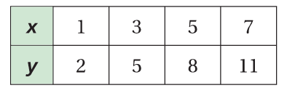
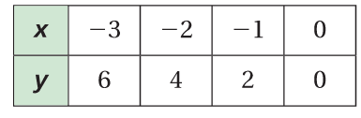
5. 6.

Write an equation for the given linear relationships.
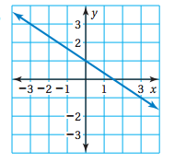
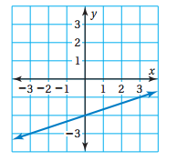
7. 8.

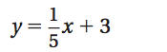
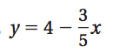
Graph the given linear equation.
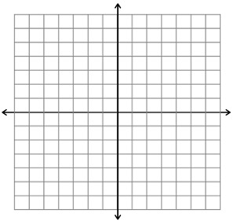
9. 10.

Write an equation of the line that passes through the points.
11. (0, -2), (4, -2)

12.) Mrs. Colville’s cell phone provider is Verizon. She pays $60 for her plan and then an additional $20 per line.
a) What is the slope of the line? Justify your reasoning.

b) What is the y-intercept of the relationship above? Justify your reasoning.

c) Write an equation for the total cost c of the bill given the number of phones p on the plan.

13.) Create your own linear situation. Explain how you know what the slope and the y-intercept for your given situation.

For #14 find the x and y intercepts, graph the equation using the intercepts and rewrite it in Slope-Intercept Form. For #15, write an equation in Point-Slope Form, graph it and rewrite it in Slope-Intercept Form.
14. x + 3y = -3
x-intercept
y-intercept

Slope-Intercept Form

15. m = - 4 and (1,2) Point-Slope Form

Slope-Intercept Form

The Term 3 Assessment will cover the following concepts:
Review of Term 3 Concepts:

Unit 3-Part 2

16 - Solve Systems of Equations by Graphing
17 - Solve Systems of Equations by Substitution and Elimination
18 - Functions

Solve each of the systems of linear equations below by graphing. Be sure to express your solution as an ordered pair.
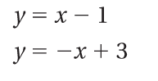
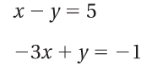
16. 17.

Solve each of the systems of linear equations with substitution or elimination. Choose the method that the problem lends itself to more naturally. Be sure to express your solution as an ordered pair. Make sure to solve using BOTH elimination and substitution at least once on this quiz. Show your work.
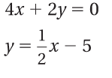
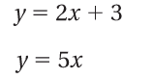
18. 19.

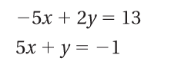
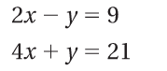
20. 21.

22. Kayla is starting a t-shirt business. She purchases t-shirts for $5 each and spends $80 in signs for advertising. She plans to sell the t-shirts for $15. How many t-shirts must she sell to break even? Provide evidence to justify your answer.

23. What are the characteristics of systems of equations for the following situations:
No Solution | Infinite Solutions | One Solution

For #24-25, list the ordered pairs in the mapping diagram. Then determine whether the relation is a function. For #26-27, write the equation that describes the function shown by the table.
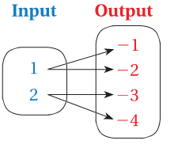
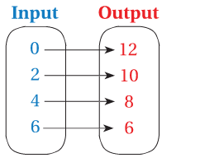
24. 25.

x | -1 | 0 | 1 | 2
y | -2 | 0 | 2 | 4
26.

x | -6 | -4 | -2 | 0
y | -11 | -7 | -3 | 1
27.

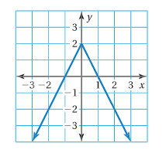
For each of the relationships below, determine whether they are linear or non-linear functions. Specifically explain your answer.
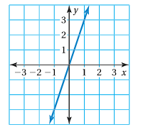
28. 29.

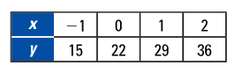
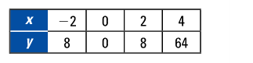
30. 31.

32. What is the difference between just a function and a linear function?

