Name _____________________ Date ____________ Hour _________
7th Grade Advanced – Unit 1 Assessment - Study Guide (Part 2)
The Unit 1 Assessment Part 2 will cover the following concepts:
- 4 - Angles
- 5 - Classifying and Constructing Triangles/Quadrilaterals
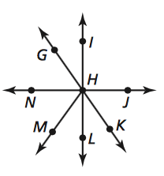
Use the diagram below to answer the following questions.
2x
3x
x + 18
2.5x + 9
- < IHN is a right angle.
Find the measure of < GHN.
54 - x
- Find the measure of < MHL.
- Find the measure of < KHJ.

- List two of the following types of angles and explain/justify why.
  - Vertical Angles

  - Adjacent Angles

  - Complementary Angles

  - Supplementary Angles

- <ABC and <CBD are a supplementary linear pair and share a vertex at point B.

<ABC = 2x
<CBD = 5x+40

Draw a labeled diagram that fits this scenario. Then, find the value of x. (Show your work.)

Classify each of the following polygons and find the missing angle(s).

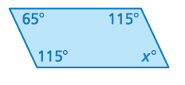
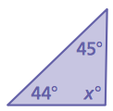

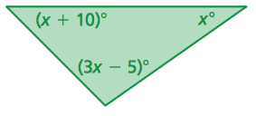

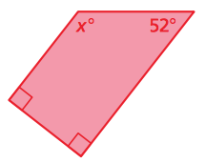

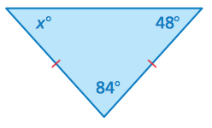
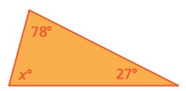

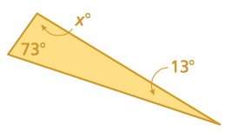
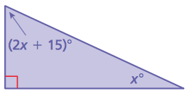

Construct the following polygons.

- A trapezoid with a pair of congruent sides.

- A parallelogram with a 75⁰ angle and a 4-centimeter side.

- A scalene triangle with a 4-centimeter side and a 6-centimeter side.

- An isosceles triangle with two 3-centimeter sides that meet at a 100⁰ angle.

