Name Date

Practice A

12.5

1. Use the drawing of the game court and an inch ruler. Each inch in the drawing represents 8 feet.

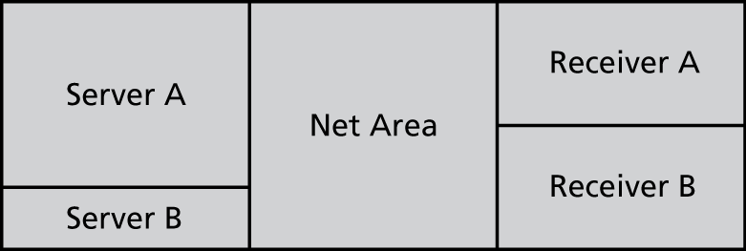

1. What is the actual length of the court?
2. What are the actual dimensions of Receiver A?
3. What are the actual dimensions of the Net Area?

Find the missing dimension. Use the scale factor 1 : 5.

2. Model: 3 ft 3. Model: 7 m

Actual:  Actual: 

4. Model:  5. Model: 

Actual: 20 yd Actual: 12.5 cm

6. A scale drawing of a rose is 3 inches long. The actual rose is 1.5 feet long.

a. What is the scale of the drawing?

b. What is the scale factor of the drawing?

7. A scale factor is 1:8. Describe and correct the error in finding the model length that

corresponds to 48 feet.

