Name Date

Practice A

12.3

Classify the triangle.

1. 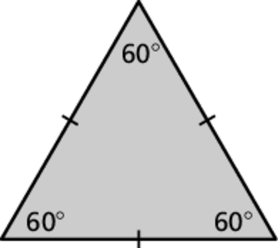 2. 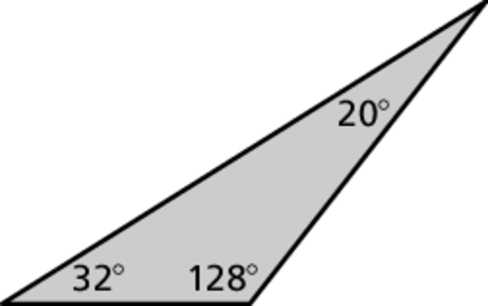

3. 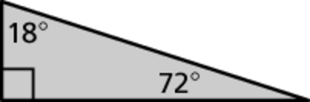 4. 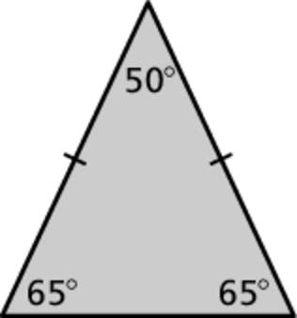

Draw a triangle with the given description.

5. a right triangle with two congruent sides

6. a scalene triangle with a 3-inch side and a 4-inch side that meet at   
a angle

7. Consider the three isosceles right triangles.

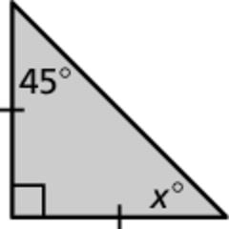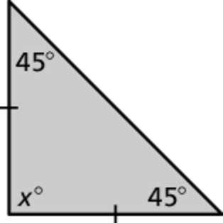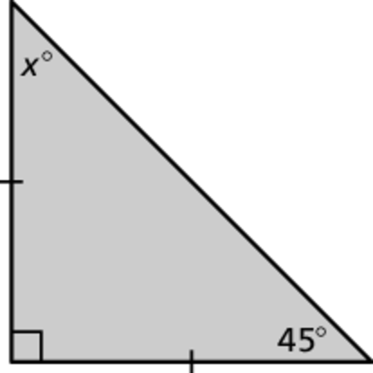

1. Find the value of *x* for each triangle.
2. What do you notice about the angle measures of each triangle?
3. Write a rule about the angle measures of an isosceles right triangle.

Draw a triangle with the given angle measures. Then classify the triangle.

8.  9. 