Name Date

Practice B

12.3 & 12.4

Classify the triangle.

1. 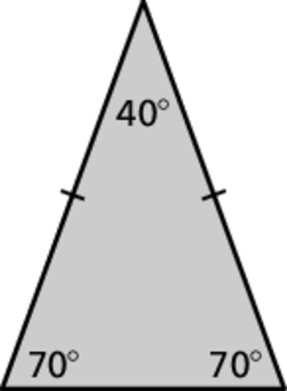 2. 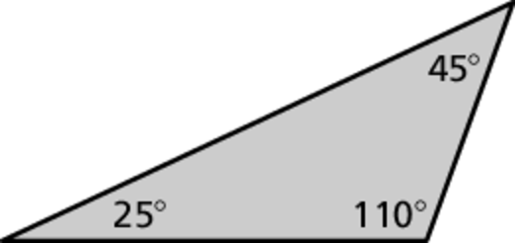

Draw a triangle with the given angle measures. Then classify the triangle.

3.  4. 

**Draw a triangle with the given description. LABEL your triangle.**

5. an obtuse scalene triangle

6. a triangle with a angle connected to a angle by a 6-inch side

Name Date

Practice B

12.3 & 12.4

Classify the quadrilateral.

1. 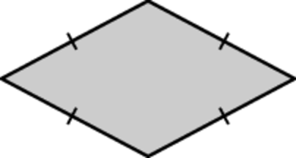 2. 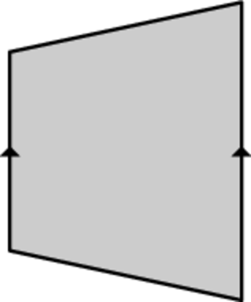

Find the value of *x*.

3. 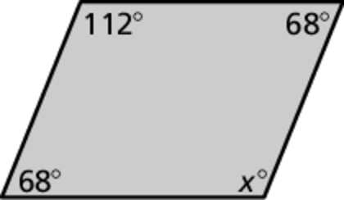 4. 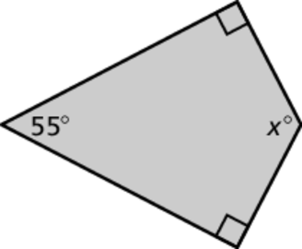

**Draw a quadrilateral with the given description. LABEL your quadrilaterals.**

5. A rhombus with side lengths of 4 cm and a 30° angle.

6. A parallelogram with side lengths of 3cm and 6 cm and an angle of 40 °.